

International Expert Workshop

on Land Take

4-5 April 2019 in Berlin, Germany

Workshop Report

compiled by:

Dr. Jana Bovet, Dr. Elisabeth Marquard & Dr. Christoph Schröter-Schlaack

**Helmholtz Centre for Environmental Research – UFZ**

**Final version**

Leipzig, November 2019

The SURFACE project is funded by the German Environment Agency (Umweltbundesamt – UBA)

FKZ: 3717 18 110 0

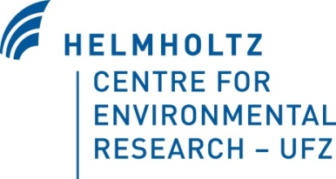

Content

1. Introduction 3

1.1. The SURFACE project 3

1.2. Background: International land take reduction targets 4

2. The SURFACE expert survey on land take 4

2.1. Preliminary insights 6

2.1.1. Current situation of land use and land take 6

2.1.2. Strategies and political background of land take control (incl. SDGs) 9

2.1.3. Goals/objectives and monitoring 11

2.1.4. Instruments for the reduction of land take 15

2.1.5. Overall assessment of strategies, goals, and instruments to control land take 17

2.2. Preliminary Conclusion 19

3. The SURFACE expert workshop 20

3.1. Objectives and approach 20

3.2. Discussion in Breakout Groups 22

3.2.1. Breakout Group "Awareness Raising" 22

3.2.2. Breakout Group "Monitoring & Indicators" 25

3.2.3. Breakout Group "Instruments for reducing land take" 27

4. Overall summary & Outlook 29

Appendix A: Indicators mentioned in answers to question 3.4 (quotes) 31

Appendix B: Program of the SURFACE Expert Workshop in April 2019 36

# Introduction

## The SURFACE project

The full title of the SURFACE project is “(Inter)national Standards and Strategies for the Reduction of Land Consumption”. The project is funded by the German Environment Agency (UBA) from 2017-2020.

The term ”land consumption”, and its synonym “land take”, describe the conversion of semi-natural and natural land (including agricultural areas and forests) into developed land, e.g. for urban or other residential and transport purposes. In the following, we predominantly use the term “land take” to be consistent with the wording in several EU documents (e.g. in the Roadmap to a Resource Efficient Europe[1]) and with the land take indicator monitored by the European Environment Agency (EEA)[2].

Land take comes along with many negative ecological, economic and social consequences and should therefore be minimized. However, the underlying causes of land take are manifold and interacting and, so far, the public pays relatively little attention to the problem. Both, the complexity of the drivers and the lack of awareness, make it difficult to develop, agree on and implement effective policy measures. As a result, land take is one of the most persistent environmental problems in large parts of the European Union (EU). Across the 28 EU member states, total land take mounted up to over 1000 km2 (approx. 100.000 ha) per year in 2000-2006. While the EEA recently concluded that this rate has decreased to 539 km² per year in 2012-2018[3] (the measures for both time periods are based on Corine Land Cover data), Eurostat found evidence for an accelerating rate of land take within the EU between 2012-2015 as compared to 2009-2012 (based on data from the Land Use and Cover Area Frame Survey, LUCAS, for EU-23 excluding Bulgaria, Cyprus, Croatia, Malta, Romania)[4].

In any case, land take proceeds to affect more and more area in Europe. This trend continues, despite the fact that land take has been a topic on the political agenda in some EU member states for years, and political targets to reduce negative impacts of human activities on land and soils have been adopted in some of the European countries and at the European and international level (see section 1.2 below).

The SURFACE project explores the current situation with regard to land take in several different EU- and selected non-EU-countries with the aim to identify promising policy approaches, factors hampering progress toward agreed targets, and steps that could be taken to advance the ‘land take issue’ within the EU. Of particular interest are commonalities and differences among the countries and insights are sought along the following lines:

1. Which objectives and instruments for the reduction of land take exist in the selected countries?

2. What kind of indicator sets and monitoring concepts are suitable and feasible for land take?

Furthermore, the SURFACE project seeks to stimulate knowledge exchange among scientific experts and decision makers and to promote efforts to reduce land take in Germany and Europe.

## Background: International land take reduction targets

As mentioned above, the goal to reduce negative impacts of human activities on land and soils has been incorporated in several policy documents. For example, in 2011, the EU Commission proposed that: “By 2020, EU policies take into account their direct and indirect impact on land use in the EU and globally, and the rate of land take is on track with an aim to achieve **no net land take by 2050** […]”**[5]**. Building on this initiative, the goal of achieving “no net land take by 2050” was incorporated into the 7th Environment Action programme[6] of the EU which was adopted by the European Parliament and the Council of the EU in 2013.

At the international level, the member states of the United Nations (UN) declared at the Conference on Sustainable Development in Rio de Janeiro in 2012 (Rio+20), that they “will strive to achieve a land-degradation neutral world”[7]. In 2015, the UN General Assembly adopted the 2030 Agenda for Sustainable Development containing the 17 Sustainable Development Goals (SDGs). Especially SDG 11 and SDG 15 provide linkages with the goal of reducing land take: Land degradation or land take is mentioned in the targets of these SDGs or is set as an indicator:

Target 11.3 reads: “By 2030, enhance inclusive and sustainable urbanization and capacity for participatory, integrated and sustainable human settlement planning and management in all countries.” One of the indicators suggested for this target is the “**Ratio of land consumption rate to population growth rate**”[8].

Target 15.3 reads: “By 2030, combat desertification, restore degraded land and soil, including land affected by desertification, drought and floods, and **strive to achieve a land degradation-neutral world**”. One of the indicators suggested for this target is the “Proportion of land that is degraded over total land area”[9].

To make progress toward these targets in the EU, a concerted effort of its member states is needed as well as the implementation of respective measures and strategies at the national scale.

# The SURFACE expert survey on land take

To assess standards and strategies for the reduction of land take in Europe and beyond, a survey was conducted covering 30 countries. The focus was on EU member states; in addition, five OECD-countries and two countries with emerging major economies (BRICS[10]) were included in the survey. Questionnaires were sent to national land take experts (more than 50 enquiries in over 35 countries). At the end of the survey, 25 experts had filled in the questionnaire, covering 21 countries. To supplement the obtained data, the SURFACE team extracted additional information from the literature (see Tab. 1).

**Table 1: Countries included in the survey on land take in Europe and beyond**

|  |  |  |  |  |  |
| --- | --- | --- | --- | --- | --- |
| **Country** | **EU** | **OECD** | **BRICS** | **Data obtained** | **Data sources** |
| 1. Austria | ✓ | ✓ |  | ✓ | 2 Questionnaires, Literature |
| 1. Australia |  | ✓ |  | ✓ | Questionnaire, Literature |
| 1. Belgium (Flanders) | ✓ | ✓ |  | ✓ | Questionnaire, Literature |
| 1. Brazil |  |  | ✓ | ✓ | Questionnaire, Literature |
| 1. Bulgaria | ✓ |  |  | ✓ | Literature |
| 1. Canada |  | ✓ |  | ✓ | 2 Questionnaires, Literature |
| 1. China |  |  | ✓ | ✓ | Questionnaire, Literature |
| 1. Croatia | ✓ |  |  |  | (Query, no response) |
| 1. Cyprus | ✓ |  |  | ✓ | Literature |
| 1. Czech Republic | ✓ | ✓ |  | ✓ | Questionnaire, Literature |
| 1. Denmark | ✓ | ✓ |  | ✓ | Questionnaire, Literature |
| 1. Estonia | ✓ | ✓ |  | ✓ | Questionnaire, Literature |
| 1. Finland | ✓ | ✓ |  |  | (Query, no response) |
| 1. France | ✓ | ✓ |  | ✓ | Questionnaire, Literature |
| 1. Germany | ✓ | ✓ |  | ✓ | Questionnaire, Literature |
| 1. Greece | ✓ | ✓ |  | ✓ | Questionnaire, Literature |
| 1. Ireland | ✓ | ✓ |  |  | (Query, no response) |
| 1. Italia | ✓ | ✓ |  | ✓ | Questionnaire, Literature |
| 1. Luxemburg | ✓ | ✓ |  |  | (Query, no response), Literature |
| 1. Netherlands | ✓ | ✓ |  | ✓ | Questionnaire, Literature |
| 1. Poland | ✓ | ✓ |  | ✓ | Questionnaire, Literature |
| 1. Portugal | ✓ | ✓ |  | ✓ | Questionnaire, Literature |
| 1. Rumania | ✓ |  |  | ✓ | Questionnaire, Literature |
| 1. Slovak Republic | ✓ | ✓ |  | ✓ | 2 Questionnaires, Literature |
| 1. Slovenia | ✓ | ✓ |  | ✓ | Questionnaire, Literature |
| 1. Spain | ✓ | ✓ |  | ✓ | Questionnaire, Literature |
| 1. Sweden | ✓ | ✓ |  |  | (Query, no response) |
| 1. Switzerland |  | ✓ |  | ✓ | 2 Questionnaires, Literature |
| 1. United Kingdom | (✓) | ✓ |  |  | (Query, no response) |
| 1. United States |  | ✓ |  |  | (Query, no response) |

As expected, the survey results demonstrated commonalities among the countries as well as national specificities. The following sub-sections present some (preliminary) insights distilled from the answers given by the national land take experts.

## Preliminary insights

## Current situation of land use and land take

**Main underlying causes for land take:**

*The conversion of land for the purposes of expanding settlements and infrastructure is a main driver of land use change in all countries from which experts participated in the questionnaire study. However, striking differences exist with regard to the extent of land take, its significance in comparison to other drivers of land use change and the underlying causes (housing / resident or industrial areas, infrastructure, etc.).*

The respondents highlighted the following underlying causes for land take: growing prosperity, population growth and the economic growth as a whole. These developments are, with respect to housing, accompanied by an increase in (smaller) households and an increase in dwelling area per person.

The increase in roads and other traffic routes is caused by an increase in individual transportation as well as the infrastructure demands of particular branches of industry, in particular for tourism, logistics and production sites (e.g. in Austria, Belgium, Cyprus, Denmark, France, Germany). In many countries, „urban sprawl“ is observed which is triggered by the construction of residential buildings (e.g. in Czech Republic, Germany, Poland, Romania), and of traffic routes, large retail markets and other urban infrastructure (e.g. in Austria, Brazil, Canada, China, Czech Republic, Netherlands, Poland). According to the respondents, these developments are not only caused by the mentioned direct and indirect developments, but partly also by deficiencies in governance or political failures which include e.g. a taxation system that incentivises municipalities to attract inhabitants and industry (e.g. in Denmark, Flanders, Germany, see also 2.1.2), weak protection of agricultural land due to financial charges for land conversion that are too low (Czech Republic), exceptions to existing regulations (Portugal), weak authorities (Greece, Slovakia), corruption and the distribution of competences across many different authorities (Romania) and short legislation periods (Italy).

Several national experts stressed significant regional differences within their countries. In Belgium and Spain, this phenomenon is particularly pronounced due to the federal / decentralized composition of these countries, which partly gives regions far-reaching powers.

**Use of the term “land take”**

*The English terms “land take” and “land consumption” have many counterparts in the different European languages that are more or less equivalent:*

In Germany, the amount of “taken land” is regularly assessed and for this purpose, the relevant process (“Flächenneuinanspruchnahme” ≈ making use of land; or, less accurately, “Flächenverbrauch” ≈ land consumption) is described as “the conversion of agricultural, natural or semi-natural land or forests into areas for settlements or recreation (e.g. sports facilities, camping sites, parks), industrial and commercial areas and areas of traffic infrastructure (road and rail traffic)[11].

The understanding of land take is the same in Austria and the slightly varying term “Neue Flächeninanspruchnahme” has been defined accordingly by the responsible Environment Agency[12]. Formerly, the respective process was commonly described as “Bodenverbrauch” (consumption of soil or territory)[13]. In both countries, Germany and Austria, the relevant expert circles aspire to use terms that capture the difference between the absolute land take accumulating over a period of time and the rate of land take per unit time. However, the corresponding terms are not always used consistently.

In Switzerland, two alternative terms are commonly used to describe land take („Siedlungs-wachstum“ ≈ growth of settlements; and „Bodenverbrauch” ≈ consumption of soil or territory).

A similar understanding prevails in Flanders / Belgium („ruimtebeslag“ ≈ making a claim on land / space), France („artificialisation” ≈ loss of naturalness / transformation into land heavily influenced by human activities) and Portugal („artifical land use“). At least in Flanders and in France, the respective concepts include unsealed areas in which the national soil functions are severely impaired (e.g. gardens, parks, camping sites). For Portugal, this could not clearly be derived from the national expert’s responses and the responses from the Austrian[14] and the Slovenian[15] experts illustrated that “land take” is sometimes not clearly differentiated from soil sealing in the national discourse.

Furthermore, terms are used in many countries (partly also legally binding) which refer directly to the growth of urban areas, examples mentioned in the questionnaires (and partly also used in several other countries) include: „expansão urbana“ = urban expansion/urban sprawl (Brazil, Portugal), „byudvikling“ = urban development and “byvaekst” = urban growth (Denmark), „urbanización” = urbanization (Spain), and „pozidava” ≈ urban sprawl (Slovenia).

In Poland, any conversion of agricultural land or forests into land used for other purposes is regarded as land take (according to the Polish expert, this can indirectly be derived from Polish law). In Slovakia (as in the Czech Republic), there is a specific legislation – the Soil protection Act – which protects agricultural land of high-quality against land take.

In Romania, Italy, Greece, Portugal and Estonia, legally or otherwise binding definitions for the term land take do not seem to exist. However, also in some of these countries, awareness with regard to land take is growing and related concepts, such as urban sprawl, land consumption and the expansion of artificial soil cover, are discussed and refined (e.g. in Italy and Portugal) – this development might be triggered by activities at the European level.

Some of the responses to the SURFACE questionnaire illustrated a conceptual confusion: the term land take was interpreted in the context of land expropriation (although a definition of the term was provided at the beginning of the questionnaire)[16].

The Canadian expert explicitly pointed to this notion of the term “land take” in English:

*„Land take is not a term used in Canada. It [is] usually referred to as land use change. ‘Takings’ in the US actually means the seizure of private property by government for public use”*

The Australian, the Chinese and partly also the Romanian expert obviously conceptualized „land take“ in this sense: e.g., when asked whether a national definition existed for the term land take, the Australian expert referred to the “Land Acquisition and Compensation Act” of 1986. The Chinese expert pointed out that, in China, a distinction is made between circumstances where land is taken by the government temporarily vs. situations in which it is taken permanently. The Romanian expert made recurrent reference to the phenomenon of ‘land grabbing’, i.e. the large-scale purchase of land by foreigners.

**Relevant forms of land degradation or soil loss**

*According to the respondents, land take / land sealing / urbanization / urban sprawl range among the most severe threats for soils functions in Austria, Czech Republic, France, Germany, Slovakia, Slovenia, and Switzerland.*

Furthermore, the following threats for soil functions were mentioned relatively frequently by the consulted experts: erosion by water / wind (incl. loss of organic matter, humus), desertification, in particular in light of climate change (e.g. in China, Greece, Italy, Portugal, Romania, Spain), contamination, pollution, excess of nutrients, soil compaction, salinization.

Loss of biodiversity and the overuse / exploitation of water reserves / of the ground water were mentioned only a few times.

## Strategies and political background of land take control (incl. SDGs)

**Land take as a topic in the political and/or professional debate**

*According to the expert views expressed in the SURFACE survey, there is a relatively high awareness of issues related to spatial planning and spatial policies in many of the studied countries (Austria, Belgium, Canada, Denmark, France, Germany, Italy, Slovakia, Spain, Switzerland). However, it remained partly unclear whether this awareness is pertinent mostly in the political or scientific arena or in both.*

In particular, the phenomenon of „urban sprawl“ has been debated politically for a long time in many countries, e.g. in Austria, Czech Republic, Germany, Italy, the Netherlands, Poland and Portugal. In Switzerland, urban sprawl has remained of highest importance in national political and scientific discussions since 2012 (Bundesgesetz über die Raumplanung of 2012, accepted in March 2013, contains the obligation to create new strategic land use plans by the Swiss cantons [Bundesländer]). This is due to the fact that only one third of Switzerland’s surface is usable for agriculture or urbanization.

The Slovenian experts reported that the issue of land take is politically discussed, but that the conversion of land into build-up areas is often regarded as a kind of collateral damage necessary for boosting economic development. In other countries, the problem of land take has been put on the political agenda quite recently (e.g. in Belgium).

In Slovakia, soil protection has been anchored in the constitution in 2017: According the amended Article 44, land is a “non-renewable natural resource that enjoys special protection from the state and society”[17]. In 2018, a new strategy was approved on the “Protection and Agricultural Land Use in Slovakia by 2024”. However, related activities still need to be developed.

In Austria and the Netherlands, a growing population is confronted with a very limited amount of still unused or developable areas. The consulted experts reported that issues related to land policy have therefore been on the political agenda for many years. In Austria, the fairly high public awareness also extends to the ecological consequences of land take. This seems to be different in the Netherlands, where the issue of land take is intensely debated in the context of urban development but less with regard to ecological questions:

*“As one of the world’s most densely populated countries, […] land for development is scarce in the Netherlands. […] In 1985, the Dutch parliament accepted a national memorandum on spatial planning in which urban densification is mentioned as a policy goal […]. However, the densification was less an issue of ecological sustainability or land thrift, but driven by social problems in city centers […]. Since then, densification policies have never left the political agenda as a major spatial strategy.”*

For some countries, debates about „urban sprawl“ (or about the more comprehensive concept of land take) were reported to be mostly held within particular professional circles, without repercussions at larger scale or in national policies (e.g. in Brazil). Also the experts from Romania and Greece judged the issue to be mostly one of the academic sphere; however, they expressed hope that land take will be dealt with more intensely at the political level in the light of the SDGs.

For example, the expert from Romania stated that:

*„Land take it is not a permanent topic is the political debate in Romania but present a high interest among professionals and academics. Romania is committed to implementing the Sustainable Development Goals at national level and will review the National Strategy for Sustainable Development to integrate the Sustainable Development Goals.”*

Also in Estonia awareness of the problem of land take is low according to the consulted expert. The country is relatively sparsely populated and the perception prevails that economic development is a clear priority (rather than, e.g., environmental protection) and that it should not be strongly regulated. The situation seems to be similar in Bulgaria and China.

**Controversies among different policy sectors / departments with regard to land take**

*The majority of the consulted experts reported that, in their respective countries, conflicts and controversies exist with regard to land take.*

According to the respondents, a fundamental conflict exists generally between economic and ecological interests: spatial austerity as well as soil- and nature protection vs. economic growth, business expansion, regional development / cohesion policy and private economic interests (such as those of landowners).

More specifically, the national experts reported the following positions of sectors to illustrate existing conflicts in their countries:

* Industry / production: frequently positions itself against a stricter regulation of land take, due to their aim to expand economically.
* Real estate developers and landowners profit from increasing prices for land and therefore also frequently reject stricter regulations. Similarly, the building / construction sector often opposes stricter regulations, since the economic profits they can make from building larger, detached villas are often higher compared to those they can gain from building smaller terraced houses or apartments.
* Agriculture: divided / ambiguous, because land take results, on the one hand, in the loss of valuable agricultural land but, on the other hand, land owners may profit from the conversion of agricultural land to building land.
* In some countries, the tax system incentivizes municipalities to attract inhabitants or industry (e.g. in Denmark, Flanders and Germany). On the one hand, they are therefore interested in a generous designation of development areas. On the other hand, they are interested in decreasing rates of land take, due to social and ecological reasons.
* Taxation: There are certain financial instruments that may incentivize land take, e.g. financial support for regional economic development or a tax reduction for commuters.
* Energy sector: Conflicts arise, e.g., regarding the question whether land may be used for renewable energies (e.g. for wind turbines).

**Interconnections between land take / land development and European strategies and activities**

*In some countries, national sustainability strategies have been adopted that place issues related to spatial planning or soil protection in the context of the SDGs (e.g. in Austria, Germany; before 2015 also in Switzerland - referencing the precursor of the SDGs, i.e., the Millennium Development Goals). However, the picture across Europe is extremely heterogeneous.*

In their answers, the involved experts furthermore took reference to the following strategies, documents, policies or initiatives: Soil Thematic Strategy, EU Road Map of Resource Efficiency („no land take until 2050“), Partnerships of the Urban Agenda of the EU, Habitat-Directive / Natura 2000; in addition, they mentioned: Leipzig Charter on Sustainable European Cities (2007); Marseille Declaration (2008), European Framework of Reference for Sustainable Cities; Toledo Declaration (2010) and Promotion of Integrated Urban Regeneration, Towards a future "European Urban Agenda".

## Goals/objectives and monitoring

**National targets addressing the problem of land take**

*Quantified targets for the reduction of land take exist in Germany, Flanders/Belgium, Luxemburg and France. In Germany, Luxemburg and Belgium, these targets are not legally binding, but expressions of political will.*

The German Sustainability Strategy (2016) sets the target to reduce land take for settlements and traffic routes to less than 30 ha/d by 2030 (at present: about 60 ha/d).

In Flanders/Belgium, a target has been set to reduce land take in a step-wise process to 3 ha/d until 2025 and eventually to 0 ha/da by 2040 (Strategic Vision of the Spatial Policy Plan of Flanders[18],[19]); in 2016, land take in Flanders amounted to 6 ha/d. For the Belgic Walloon region, there are no targets for land take.

In France, a law prescribes that land take at the expense of agricultural land is to be halved until 2020 and that urban sprawl is to be reduced. The French expert reported the following:

*„The ‘Grenelle II law’ (law no 2010-788 of july the 12th 2010): reinforces local urban planning documents objectives against urban sprawl and (but no national objective fixed). The law of agricultural and fishery modernization (Law n° 2010-874 of july the 27th 2010): fixes an objective of reduction by half of agricultural land take by 2020.”*

Furthermore, the targets of a „significant reduction“ of land take until 2035 and its further reduction are fixed in the French National „Low-Carbon“-Strategy. Also, the national Plan for Biodiversity published in 2018 sets an objective of no net land take at a term which still has to be defined.

In Austria, a quantified target for the reduction of land take had been set in 2002 as part of the Austrian Strategy for Sustainability (2,5 ha/d until 2010[20]). However, this target was not met and it was not explicitly renewed when the Sustainability Strategy was replaced by a new version in 2010 (the Strategy for Sustainable Development of the Federal Government and Federal Provinces, ÖSTRAT[21]). One of the Austrian experts consulted for the SURFACE survey explains the current situation as follows:

*“The target of ‘down to a tenth by 2010’* [i.e. 2,5 ha/d] *was not explicitly confirmed in the follow-up strategy ÖSTRAT in 2010 but indirectly it did by generally acknowledging and carrying on all content related goals from the previous strategy* […]*.”*

Similarly, a quantified target was part of the Swiss National Sustainability Strategy until 2015 (max. 400 m² artificial surface / inhabitant). This target was, however, not legally binding, and it was not transferred into the current National Sustainability Strategy. The current Sustainability Strategy contains the target to confine urban sprawl and to protect cultural and natural land as far as possible against being transformed into build-up areas but the target is not quantified.

According to the consulted expert, land take is nevertheless the central issue of spatial policy in Switzerland. A revised national spatial planning law (Bundesgesetz über die Raumplanung – RPG) came into force in 2014 which tightened zoning-related regulations (e.g., the extension of building zones needs to be justified by an objective projection of the needs and is under stricter national surveillance, cantons are obliged to reduce over-sized building areas, brownfield and inward development is promoted and agricultural / cultural land is more strictly protected).

Literature research showed that the National Sustainability Plan 2010 in Luxembourg formulated the target of reducing land consumption from 1.3 ha/day to 1 ha by 2020[22]. Measures such as a soil sealing tax, a Soil Protection Act and remediation of contaminated sites shall contribute to achieving the target.

Poland does not have a quantified target for the reduction of land take, but there are quantified targets for increasing the area covered by forests.

China set the target that the total amount of farmland must not fall below 120 million hectares (*Ecological redline policy*[23]). According to the consulted expert, a target was also set for the total extent of build-up land which must not exceed 40.719 million hectares. Furthermore, implementation regulations require that these national targets (“especially the ones concerning basic farmland”) are translated into provincial, municipal, county and township targets.

In several countries, land is legally protected if certain land-use practices are applied or the conversion of agricultural land is only allowed under certain circumstances (e.g. in Portugal, Romania, Slovenia, Switzerland, Slovakia and the Czech Republic).

In Slovakia, Act No. 57/2013 Coll. amending Act no. 220/2004 Coll., together with the Government Order no. 58/2013 Coll., significantly changed the conditions for taking agricultural land: Agricultural soils are protected in each cadastral area (min. 30 %), and if protected agricultural land is taken, levy charges need to be paid according to a soil quality ranking system. These levy charges vary between 0.5 and 20 Euro / m² for agricultural land and increase to 100 Euro / m² for vineyards.

**Responsibilities for monitoring and assessing the attainment of land take goals**

*The respective question was conceived differently among the involved experts. Some experts reported on monitoring and indicators in the context of national targets, in particular in National Sustainability Strategies, similar to the German answer, which read:*

*„Reducing land take is a goal of the National Sustainability Strategy. Assessment of goal attainment is realized via a report of the Federal Statistical Office that is being published every two years* […]*. Monitoring of land take is realized via a methodically coherent statistical evaluation of the land survey register by the Federal Bureau of Statistics.”*

In Germany, in addition to this indicator report for the Sustainability Strategy*[24]*, a national statistic on land use is published every year.

Specific institutions at the national level, responsible for or implementing monitoring programs on land take, were mentioned by experts whose countries have explicit (quantified) targets (see above) (e.g. Flanders/Belgium: Environment Department; Germany: Statistisches Bundesamt; Austria: Environment Agency).

Experts from countries without explicit land take targets rather made reference to Impact Assessments for projects and plans, e.g. experts from Denmark, Portugal and Spain. In these cases, the picture seems more diverse with numerous responsibilities:

*„The problem of urban sprawl is addressed within the formal planning system and along national, regional and local scales, constituting one of the main goals of spatial planning agenda in Portugal”*

**More details on existing monitoring programs which help to assess changes in land use, especially structural land use changes and their impacts on environmental objectives**

*In all countries of the SURFACE survey, instruments for environmental monitoring exist but only some of them explicitly address the problem of land take for settlements and traffic infrastructure (e.g. in Austria, Belgium, Czech Republic, France, Germany and Slovakia).*

The Czech and the Slovakian expert emphasized the good quality of their national information systems, in particular a comprehensive classification of soils based on the production ability, used in both countries: The Ecological Land Quality Evaluation Codes (BPEJ)[25]. The BPEJ codes inform about the main soil and climatic conditions of units of agricultural land and were “created by a complex surveying and probing of entire agricultural areas”[26]. According to the Czech expert, *The BPEJ codes*

*„have become the basis for determining the basic price of agricultural land, establishing protection categories for agricultural land, and setting the selling price of land owned by the state”*.

In Slovakia and Czechia, the BPEJ system is used for an important economic instrument of soil protection: the obligation to pay a charge for using high-quality land for non-agricultural purposes (see 2.1.4). Furthermore, a very precise soil monitoring system was established in Slovakia by the Statistical Institute of the Geodesy, Cartography and Cadastre Authority[27]: Soil environment is monitored since 1993 considering all degradation forms recognized in Slovakia, and a Yearbook on Soil resources is produced annually. For the Czech Republic, the LUCC UK database offers detailed information about long-term land use changes[28].

In other countries, land take and / or land use change is monitored as part of the general environmental monitoring or other relevant monitoring programs (e.g. in Denmark, Italy, Portugal and Spain). There seem to be substantial gaps in the relevant data in Estonia, Greece and Slovenia: For Estonia, the consulted expert reported that there is no authority responsible of monitoring land take. The Estonian Land Board recently started to collect data on land cover and use types per cadastral unit for taxation purposes, but comparable data is missing for previous years.

The Greek expert stated that “generally speaking, there are not any official monitoring programs to assess land uses and their changes.” The Hellenic Statistical Authority as well as researchers commonly use the CORINE Land Cover data to obtain information on land cover changes. Furthermore, monitoring data exists for some particular areas, e.g. for areas along the Motorway (where e.g. the rate of change of agricultural land and natural areas to urban land has been assessed by the Egnatia Motorway Observatory).

For Slovenia, the consulted experts reported that

*“there is not permanent monitoring of land use changes. However, the Ministry of the Environment and Spatial Planning sporadically controlled the intention for the land take via the procedure of the municipal strategic spatial plans preparation. More into detail, the ministry checked how much land has been designated as a build land on which there would be possibility to build in the future. However, this has not been systematically registered.“*

**Suitable indicators for land take that may help to assess progress towards respective political goals**

*The respondents named numerous potentially suitable indicators, which are currently either already in use or should be implemented according to the consulted experts. Frequently, indicators were mentioned that monitor land take (or a specific component of it) per inhabitant, per administrative unit, per unit area or per unit of time, e.g.*

* Settlement area per capita / per job / per municipality
* Sealed area in relation to total area of a municipality
* Land take per hectare
* Land take per day

Moreover, the experts frequently referred to measurements of population density, e.g:

* Population density
* Number of buildings per hectare
* Density of households

Further measures that were mentioned by the experts:

* Situation and spatial distribution of the most valuable soils
* Degradation of the most valuable soils
* Size of empty non-build-up areas
* Average building height
* Degree of intersection of living and working
* Size of green spaces and open spaces in relation to the total area of a municipality
* Size of unsealed areas (or areas of soil regeneration) in relation to the total area of a municipality

A complete list of the indicators mentioned by the questioned experts can be found in Appendix A. Analysing and evaluating this list in more detail would require to take into account the forms of land degradation or soil loss that are most prevalent in the respective countries (e.g. erosion, salinization, desertification or contamination; see above).

## Instruments for the reduction of land take

**Legal, planning, economic or informational instruments to control land take**

*The answers by the national experts showed that there is a large variety with respect to the existence and implementation of instruments for the reduction of land take across Europe. The experts mentioned several instruments related to building and spatial planning law and partly, they elaborated on some further provisions (e.g., in Denmark, urban planning is regulated by a law that restricts land take to areas that are already connected to existing build-up areas; this is meant to prevent urban sprawl, protect agricultural land and promote the efficient use of infrastructure).*

Partly, the experts also pointed to planning instruments and tools that prohibit building (“negative planning instruments”), e.g. in Slovakia and the Czech Republic, agricultural land is intensely protected. In both countries, an economic instrument is in place to counter the use of high-quality soils for non-agricultural purposes: when such land is taken, a payment is due (“levy charges” according to the BPEJ code, see previous section). Over the past decade, the respective regulations were tightened and a considerable number of exceptions from these payments were abolished[29].

In Alberta/Canada, a system of tradable land planning permits has been introduced in 2009 by the Alberta Land and Stewardship Act[30]. The so-called Transfer of Development Credit (TDC) scheme[31] “is an enabling tool that helps addressing urban growth pressures on the land by offering an incentive to redirect development away from specific landscapes to protect open spaces”[32]. According to information provided by Alberta’s Land Use Secretariat (subject to directives issued by the Minister of Environment and Parks), “some Alberta municipalities are already exploring options in developing TDC programs”[33]. However, the consulted expert stated that

*“In practice, the use of these tools remains very limited”.*

Tradable land planning permits are also used in France, where it is possible to trade with planning specifications made in land-use plans (e.g. construction height or degree of sealing). Trading is possible between areas that are defined in the plan and those for which purchases are permitted. In this way, a property owner can increase the degree of density defined for his property by purchasing building rights. In return, the seller waives the right to build on his property. The legal basis for this trade is L 151-25[34].

In Austria and especially Germany, tradable land planning permits are discussed by academia. In Germany, this tool has been tested in a large-scale simulation in which nearly 100 municipalities took part[35].

**Innovative instruments that are currently developed / debated**

*The following list exemplifies some of the instruments that were mentioned by the experts as being innovative or promising:*

* Ecologicalisation of the public finances compensation schemes (Austria)
* Assessment of soil functions along planning processes (Austria)
* Differentiation or reform of the property tax (e.g., Austria, Germany)
* Tradable land planning permits (Austria, Germany, Belgium, Canada)
* Building bans for valuable natural resources (Austria)
* Negotiated land use planning (Austria)
* Infrastructural cost calculator (e.g. NIKK in Austria[36])
* Agglomeration programs (Switzerland)
* (Established) Planning Act‘s rules of planning (Denmark)
* Penalties, e.g. „underdensity payments“ (France)
* Generalization of the “avoid, reduce or offset” principle to smaller projects (France)
* Distance rules for renewable energy projects (Poland)
* Alignment of spatial planning instruments and of national strategies with the SDGs and their indicators (Portugal, Spain)
* Land recycling (Austria)

Whether these instruments are indeed „innovative“, in the sense that they are novel and - possibly - particularly effective, cannot be judged from the questionnaires alone. This would require more detailed descriptions of the individual instruments but even if such were provided, they would still have to be evaluated in the context of the respective entire national planning and regulative system. It may well be that some of these instruments would indeed fill gaps in the respective national juridical or planning system and would therefore classify as innovative, while the same instrument could be already in place, i.e. part of the established system, in other countries.

## Overall assessment of strategies, goals, and instruments to control land take

**Personal assessment of strategies and instruments for controlling land take in the respective countries**

*Many of the respondents replied reluctantly to this question, referring e.g. to a lack of evaluations of existing instruments (e.g. Belgium, Canada).* For Belgium, this was explained by the recent character of the instruments. For Canada, the lack of clear targets for land take and the variation of instruments and political will across different provinces were pointed out as additional challenges for assessing the effectiveness of strategies and instruments.

In France, a respective evaluation is expected for 2019:

*„There are evaluations of some land take policies, but no comprehensive ones. A full evaluation of land take policies is planned by 2019 as part of the Plan for Biodiversity.”*

Instruments explicitly highlighted by the experts as positive examples were, inter alia, quantified targets for reducing land take (e.g. Germany), specific laws or law initiatives (e.g. Denmark, Italy, Czech Republic, Slovakia), as well as the more “traditional” planning instruments (e.g. Netherlands, Slovenia, Switzerland).

**Reasons why such strategies and instruments are missing**

*The answers to this question fell in two different categories: First, some of the experts identified very general challenges:*

The Italian expert referred to a general political failure due to short election periods: between 2012 and 2016, attempts to establish national regulations on land take failed three times because the governments changed before they were able to approve respective legislative proposals.

The Greek expert saw predominantly an implementation failure and reported that land use strategies are not implemented properly in Greece and land use is not effectively controlled. The Polish expert saw an obstacle in the fact that, for Poland, a general overall strategy for the reduction of land take is missing.

The Slovakian expert reported that a special law protects soils from land take but that, in practice, frequent exceptions are made when implementing the law, for example “for development of areas of general social importance”.

For the remaining countries, the questioned experts rather identified challenges linked to the planning system or the planning practice:

The Austrian and Belgian experts, e.g., pointed out that quite large amounts of building land remains undeveloped although building permits were granted many years ago. As the Austrian expert explained, this may trigger urban sprawl “as new land permits have to be issued at the outskirts of settlements”. For the Netherlands, the respective experts highlighted the fact that there is an actual need for new housing projects due to an increasing population (while the country is already densely populated).

For Estonia, the expert instead stated that, in her country, cities are relatively small and the population density low. This results in little awareness for the problem of land take.

**Appraisal of current or prospective national policy trends regarding the control of land take and related activities to contribute to SDGs 11 and 15**

*Again, the answers to this question were rather diverse.*

For Germany, the Sustainability Strategy was regarded as the central strategic framework for implementing the SDGs. It addressed land take already before the adoption of the SDGs: Since 2002, it includes the target to reduce land take to 30 ha per day until 2020. In 2016, Germany’s Sustainability Strategy was relaunched and the land take target was reformulated as “under 30 ha per day until 2030”. A specificity of the Strategy is that it has been developed jointly by all ministries, and adopted by the German Cabinet. Its implementation and surveillance is steered by the State Secretaries’ Committee for Sustainable Development which is chaired by the Head of the Federal Chancellery. The consulted experts further point out that the current coalition agreement of the reigning political parties in Germany has taken up the 30-ha/d-target. With regard to the SDGs, they conclude that SDG 11 is the most relevant one for the land take issue in Germany since SDG 15 is not equipped with relevant indicators in the national Sustainability Strategy (focusing instead on biodiversity, ecosystems and forest, not on land degradation). An Inter-Ministerial Working Group on Sustainable Urban Development has been set up which “approaches urban issues from a national and international perspective”[37].

A different picture was drawn for Austria where the linkages between the national sustainability strategy (ÖSTRAT) and the SDGs of the UN (and their implementation at the EU level) seem to be less obvious, since the Austrian strategy still builds on the precursor of the SDGs (the Millennium Development Goals). However, the activities of the Austrian Conference on Spatial Planning (ÖROK) with regard to SDG 11 were highlighted as “a remarkable step forward” by the consulted experts.

In several countries, land take and/or urban sprawl seem to be increasingly addressed politically, and partly, this seems to be supported by the SDGs (e.g. Czech Republic, Portugal, Slovakia, Slovenia).

In two Eastern European countries, Bulgaria and Romania, the issue of reducing land take seemed to have not really gained political grounds so far.

Some experts expressed hope that an impulse for combatting land take will be received via the SDGs (e.g. Greece, Romania).

## Preliminary Conclusion

Based on the answers of the 22 national experts from Europe involved in the SURFACE survey, Belgium (Flanders)[38] and Germany seem to be pioneers with regard to setting quantified land take reduction targets. In Austria, France and Switzerland, land take is also intensively debated and administratively addressed but without quantified national reduction objectives. In all of these five countries, there seems to be a fairly high awareness of the problem, comprehensive planning procedures in place and fairly detailed monitoring data is available. Nevertheless, it cannot be concluded from this that these are the five countries where the degree of urban sprawl and the level of land consumption are the lowest, since land policy wasn't necessarily that consistent in the past. In fact, the measures that are in place at the present time have partly been a response to high levels of land take, e.g. in Flanders and Germany. According to recent data provided by the European Environment Agency for 2012-2018, the yearly land take in proportion of the country area was indeed above the EEA-39 average (150 m²/km²) during this time period in Belgium (195 m²/km²) and Germany (158 m²/km²), somewhat below average in France (144 m²/km²) and Austria (135 m²/km²), and comparatively low in Switzerland (50 m²/km²). These figures need to be interpreted with great caution, however, e.g., they need to be considered in relation to the size of the land that is suitable for e.g. agriculture, housing, or other purposes. Furthermore, they cannot necessarily tell whether recently established measures to confine land take are successful or not, since more time may need to pass until these measures generate significant effects (e.g. the quantified target in Flanders).

Furthermore, the problem of land take seems to be debated relatively dynamically in Italy, the Netherlands, Poland, Portugal, Slovenia and Spain, however, embedded in very different national contexts. In countries that where heavily hit by the financial crisis in 2008 and/or underwent profound economic and societal changes during the post-communist era, reducing land take seems to be regarded predominantly as being in conflict with economic growth. In the Netherlands, a high population pressure and a respective tense real estate market seem to be additional factors hampering more restrictive spatial policies.

In Denmark, regulative instruments and monitoring programs are largely lacking at the national scale. However, the objective to save land from being taken seems relatively successfully implemented at the municipal level for several decades. Furthermore, the issue of land take reduction seems to enter national politics increasingly via matters related to climate change (e.g. related to hail insurance, coast line protection).

The Czech Republic and Slovakia stand out with regard to their monitoring systems which produce very detailed databases on agricultural soils. Both countries have laws that prohibit the conversion of high-quality agricultural land and a respective economic instrument in place, but in practice, exemptions are made in favour of economic or other social interests.

Low awareness and few political activities were identified for Estonia, Greece, Bulgaria and Romania. The respective experts expressed hope to change this situation, in particular in the light of the implementation of the SDGs.

# The SURFACE expert workshop

## Objectives and approach

The questionnaires of the SURFACE survey contained a wealth of relevant information and the detailed answers of the national experts pictured the situation of land take in its great variety across 21 different countries of which 16 are members of the EU (see Tab. 1 above). Significant differences and similarities between countries or country-specific instruments could be identified and some preliminary conclusions were drawn (see Chapter 2 above). However, the country reports could only provide an incomplete picture, as only one or two national experts were involved in the survey per country. Furthermore, the survey did not allow a comprehensive assessment of the effectiveness of national instruments for the reduction of land take because this would require a much more detailed study of individual instruments and their functioning in the country-specific political and legal contexts. Last but not least, the survey also highlighted the difficulty of creating a common understanding and using terminology consistently across such a large number of different countries and (mostly non-native English speaking) experts. The SURFACE expert workshop provided room for discussing these challenges.

In addition, the workshop offered the opportunity to exchange further information among the involved experts, which was explicitly welcome by several participants. In particular, the presentations on the situation in each of the countries provided additional insights, which could not be obtained easily through a pure study of the questionnaires and the literature.

In summary, the objectives of the SURFACE expert workshop were the following:

* Deepening the understanding of the country-specific situation of land take in several European countries
* Providing an opportunity for knowledge exchange and networking among experts
* Initiate the discussion on jointly writing a manuscript and possibly on further collaborations.

The workshop took place in April 2019 in Berlin. In addition to the SUFACE team, 14 experts from a total of twelve EU countries[39] and four representatives of the German Environment Agency (UBA) participated in the workshop. In order to meet the objectives, a workshop procedure was chosen that allowed room for country specific presentations and for a discussion phase during which national perspectives could be exchanged, also in light of the European and global policy approaches and targets. This allowed identifying gaps and obstacles, mostly from a scientific point of view (the majority of the participants were associated to scientific institutions).

The workshop started with a short introduction of the SURFACE project and of expected outcomes of the workshop (Detlef Grimski, UBA), followed by a presentation on the project’s current status and first results (Jana Bovet, UFZ). Subsequently, a presentation on "The implementation of soil and land-related sustainable development goals (SDGs) at EU level - current status" provided information on related activities of a different EU-funded project (Linda Maring, DELTARES).

To streamline the country specific presentations, all participants had received the following five key questions as basis for their presentation:

* Level of awareness: How would you describe the level of awareness of policy makers, the public and the scientific community for the problem of land take?
* Policy discussions on strategies to combat land take: Are there policy discussions on strategies to combat land take in your country at the national level, how are they linked to the implementation of SDGs, in particular SDG 11 or SDG 15?
* Monitoring programs and indicators: Which relevant monitoring programs (i.e. land use statistics) exist in your country and which indicators are used?
* Efficiency of national policies, ideas for improvements: How do you judge the efficiency of national policies, which legal or political obstacles hamper progress and what could be improved by national or European regulations?
* National specificity: Is there a national specificity that should be mentioned but does not fit properly to questions 1) – 4)?

For the complete workshop program, see Appendix B. All presentation slides can be found in the Annex to this workshop report.

## Discussion in Breakout Groups

One main objective of the workshop was to obtain a deeper understanding of the national policy strategies and to exchange information and ideas on how to better assess the potential of the different attitudes, approaches and instruments. To this end, three breakout groups were composed, providing an informal space for knowledge exchange and networking between the actors. The topics discussed in these breakout groups were

* Awareness raising for land take,
* Indicators for monitoring land take,
* Instruments for reducing land take.

The workshop participants had the possibility to choose two of the breakout groups and to discuss the two topics they were most interested in (each topic for 45 minutes). After the participants had changed the groups, the facilitator of the group introduced them to the discussion and results of the first group. Thereby, the points raised during the first discussion round could be taken up during the subsequent round. In both rounds, all suggestions, points of criticism and ideas were written down. Finally, some topical clusters were identified to structure the manifold suggestions and discussions and they were reported in the entire group during the final plenary discussion.

## Breakout Group "Awareness Raising"

A central insight from the expert presentations and interpretations of the national status quo of land take containment in different European countries was the importance of (increased) awareness of the value of soils and open space and thus for the need to regulate land take and urban development. Against this background, the first breakout group aimed at looking more deeply into the issue of "awareness raising" for soil protection and regulation of land take.

During the first round, participants were asked to brainstorm on obstacles and difficulties for land take regulation with regard to a lack of awareness and also on opportunities and potential solutions that would help placing these issues more prominently on the table of policy- and decision-makers as well as the general public. During the second round, other national experts revisited the results of the first group and commented and complemented them. Finally, some clusters were identified to structure the manifold suggestions (see Fig. 1, obstacles and challenges were collected on red cards, opportunities and potential solutions on yellow cards, clusters on blue circles).

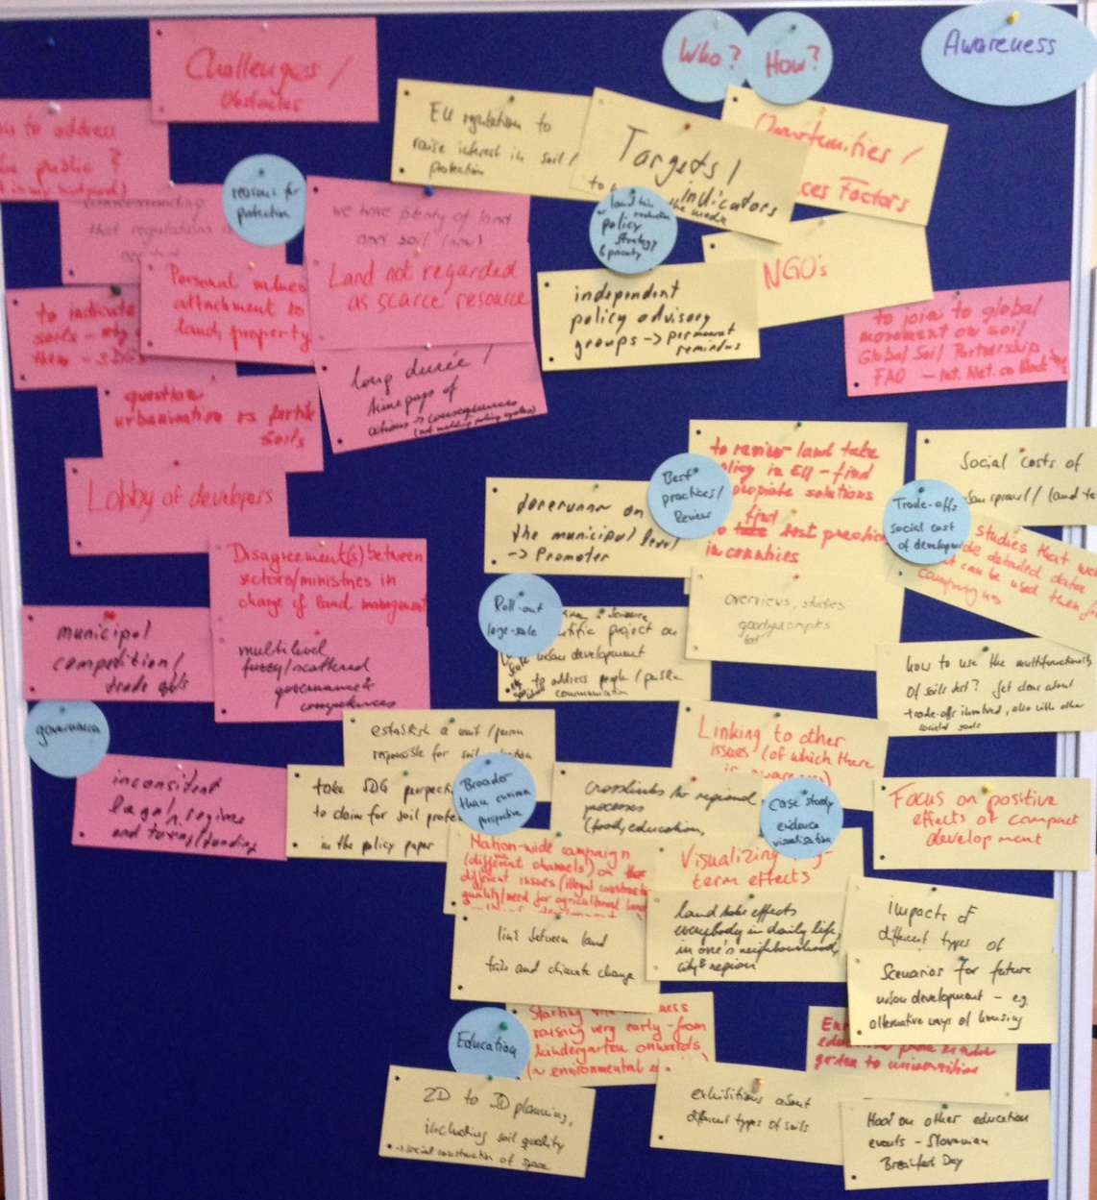

Figure 1: Results from the breakout group "Awareness Raising"

A shared perception of participants was that the challenge of land take and the resulting impacts are not commonly understood and recognized by the relevant actors. Although in some countries, political goals on reducing land take are anchored in sustainability strategies, process toward such objectives is hampered by a lack of political will to take (political) action or by weak implementation and enforcement of existing regulations. In other countries, land take is not a political issue as the need for protecting land and soils is not recognized by the general public and the interest in economic development is much more pronounced in the public debate. Against this background, participants stressed the need for land take entering the national political agendas and for support of this process, e.g. via European activities (e.g. Soil Framework Directive) that may foster also the establishment of national land take targets. Concentrating soil and land related competencies within one ministry / agency, convening an independent advisory council on land take and soil protection or supporting NGOs in taking a stand against land take and urban sprawl were further suggestions brought up by the participants.

Another commonality in participant's reflections was that ‘hooking’ land take to other (political and societal) challenges that have already gained attention might offer an opportunity to raise awareness on the need to reduce land consumption. Issues like climate change mitigation and adaptation, energy efficiency as well as improving public health and reducing related costs to society are well suited to be connected to compact urban development.

A third reflection was that it is necessary to reveal (long-term) impacts of land take and urban sprawl to identify trade-offs involved with e.g. agriculture, the provision of regulating ecosystem services or nature conservation. If one could demonstrate that land take involves yet unrecognized costs to society (and is not only fostering economic development, job creation or tax income) this would help creating a more balanced view on further land consumption. In this regard, calculating or modelling (higher) costs associated with less dense development and benefits of compact city development could be helpful. This holds true for public decision makers as well as for private households who may encounter higher (long-term) private costs of moving out from cities (longer commuting distances, car-dependency, reduced availability of health and other public services)[40].

Last but not least, another important perception that was shared by participants was the importance of education on soils and their societal significance. Education on these topics should start early on (e.g. in pre- and primary schools) but should also be included in curricula of (urban) planners or landscape architects in universities. Experiences with different formats and approaches were exemplified. Also citizen-science-projects were mentioned as a great opportunity to reach-out to people.

The manifold ideas on how to raise awareness on soil protection and land take reduction raised in the group discussion could be structured according to different addresses (see below). Besides national policy makers that set the broader frame for economic policies and land development (e.g. by establishing land take goals or implementing instruments), decision makers at the regional and local level are important when land consumption and protection of soils should get more attention in often localized urban planning. Finally, there is a need to raise awareness in the general public to help establishing land take reduction as a politically important goal as well as for increasing the acceptance of land take regulations.

* **Awareness raising among (national) policy makers might be fostered by:**
  + Emphasizing the importance of soils and open space to SDGs or other societal goals like climate change mitigation / adaptation, public health etc.;
  + Disclosing social costs of land take and the trade-offs involved in land development (e.g. with regard to agriculture, regulating ecosystem services, nature conservation etc.);
  + Setting national targets and reporting progress on attainment;
  + Pooling soil and land-related competencies in just one agency / ministry;
  + Joining related political initiatives, like the Global Soil Partnership;
  + Reviewing land use policies / land take regulations across different countries.
* **Awareness Raising among (regional/local) decision makers could be facilitated by:**
  + Demonstrating case-study based estimates on public costs of land take and land development;
  + Providing decision-support on how to mitigate trade-offs at local level;
  + Identifying and promoting best practice-examples and scenarios of (compact) urban development.
* **Awareness Raising among the general public could be supported with:**
  + Education (early on, long term);
  + Citizen-science-projects;
  + Communicating personal (long term) negative impacts of loose development and positive effects on living in a compact city;
  + Developing alternative pictures of (compact) city development / urban realities.

## Breakout Group "Monitoring & Indicators"

Several national and international obligations require the monitoring and reporting of land-use changes. Regarding land take, several relevant political goals exist at the supra-national level, such as the Sustainable Development Goals (SDGs) on cities and land (SDG 11 and 15), the ‘land degradation neutrality’ vision endorsed by the parties of the UNCCD and the objective of ‘No net land take by 2050’ incorporated in the 7th Environment Action Programme of the EU (see section 1.2 above). To monitor whether progress is achieved towards these political goals, it is necessary to harmonize methodologies and indicators across countries. However, the results of the SURFACE expert survey suggested that the availability of relevant data is highly variable across Europe, and that the same is true for the use of certain methodologies, the distribution of responsibilities and the conceptualisation of monitoring programs. Such a heterogeneous picture was confirmed by the expert presentations during the workshop.

Against this background, one of the breakout groups centred its discussions on the following questions:

1. How could the monitoring of land-take and the reporting of relevant indicators be improved in Europe?
2. Would certain political specifications help to make better use of the existing data?
3. Which additional indicators could be suitable to monitor land-take at the national and the European scale?

During the first round of the breakout group discussion, participants focused on questions two and three and they were also asked to reflect whether proposed activities or other suggestions would be most relevant at the national, European or international scale (or at all scales). During the second round, participants commented on the notes taken during the first round and additionally tackled question 3.

The points raised were documented with cards on a pin board (see Fig. 2, obstacles and challenges were collected on red cards, opportunities and potential solutions on yellow cards). The clustering (blue circles) was done by the facilitator in order to report the discussions back to the plenary in a structured way.

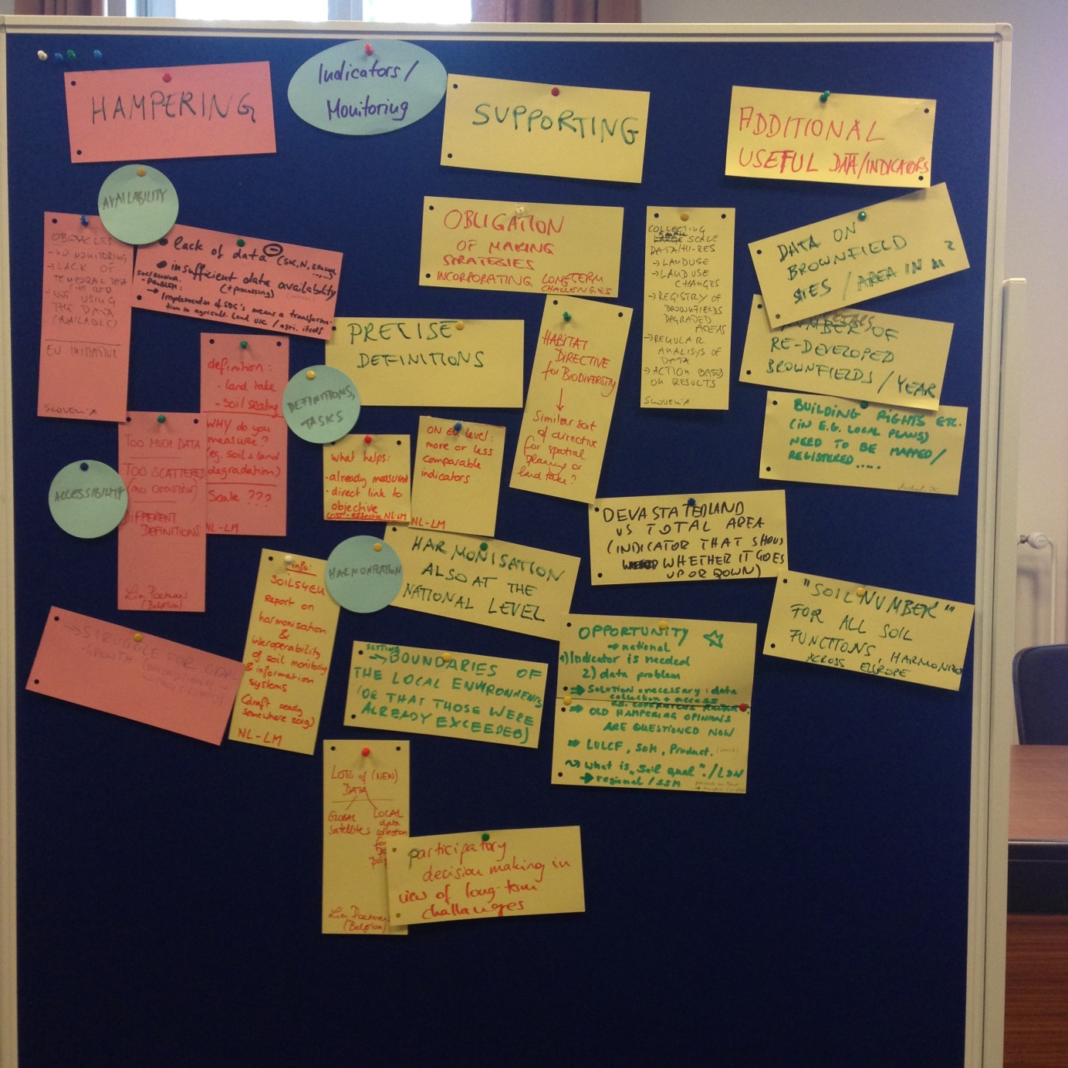

Figure 2: Results from the breakout group "Monitoring & Indicators"

As mentioned above, the situation with regard to land take monitoring and indicator use is very heterogeneous across Europe. This was again confirmed by the contributions of the participants during the two rounds of breakout group discussions.

As major obstacles, the following were identified:

* Data availability and accessibility
* Lack of clarity regarding definitions, tasks / the purpose of monitoring
* Sometimes, there is “too much data”
* Harmonization of methodologies and indicators (needed also at the federal / national level)

As supportive / useful, the following was mentioned:

* European legislation, similar to the habitat directive
* Obligation for developing strategies (e.g. at the municipal level) – an example was reported from the Netherlands
* Introducing the concept of a “soil number” for all soil functions (not only for agricultural purpose)
* European concerted effort for monitoring land take (similar to the CORINE land cover initiative, but with a finer grain)
* Some initiatives are already going on that support the harmonisation across Europe, e.g. the Soil4Europe project which addresses the interoperability of soil monitoring and information systems (DELTARES).

As additional indicators that would be useful in the context of land take, the following were proposed:

* Devastated land vs. total land area
* Area of re-developed brownfields per year

## Breakout Group "Instruments for reducing land take"

The discussion in the breakout group „Instruments for reducing land take“ focused on general aspects that foster or hamper instruments for reducing land take. Different national policies were compared in order to recognize similarities and differences between the respective contexts. Participants of both discussion rounds stressed the need for environmental legislation characterized by a straightforward, reliable policy or strategy. In particular, the sectorial policies and conflicting objectives would have to be overcome and interactions between the technical and the political system need to be sought. These claims for creating enabling conditions were substantiated by a call for a "Soil Directive" and an "IPCC for Land take”. A similar top-down approach was suggested for the national level when it was demanded that objectives and national strategies should be articulated by the government in order to raise commitment at the regional and local level. The fact that responsibilities are partly decentralized within countries and that there is competition between municipalities was acknowledged as a complicating factor in this context. Lack of awareness was mentioned as the central hampering factor (linking the discussions to the respective other breakout group). Specifically, the following challenges were pointed out:

* Lack of awareness regarding multifunctional soils as valuable natural capital;
* Lack of awareness at local level;
* Lack of inter-municipal cooperation;
* Lack of enforcement of the instruments for land take reduction.

Additionally, but only once, corruption was mentioned, which is certainly a very fundamental obstacle for the implementation of instruments for land take. With regard to the lack of awareness, the discussion focused on the question of how to foster the generation of adequate knowledge and a detailed and official monitoring system was identified as indispensable. It was suggested that countries could share the same diagnostic tools and turn them in a European policy. Participants of the second round of discussion questioned this initially plausible demand: it was doubted whether the provision of good information would be sufficient. The examples mentioned by Denmark and The Netherlands, where sophisticated monitoring programs are lacking, illustrated that data availability was not an indispensable ingredient of a good land use policy.

Market pressure was seen as an overarching obstacle - there was simply a need for housing. The economic aspect was turned into a positive one by the hinting at circumstances in which price signals may also support instruments for land take (e.g. in Slovakia with regard to the value of ESS). Finally citizen's participation was mentioned as a fundamental success factor for land take reduction policies. This aspect was endorsed by both working groups, but also raised questions about whether there were instruments for it or what these instruments should look like.

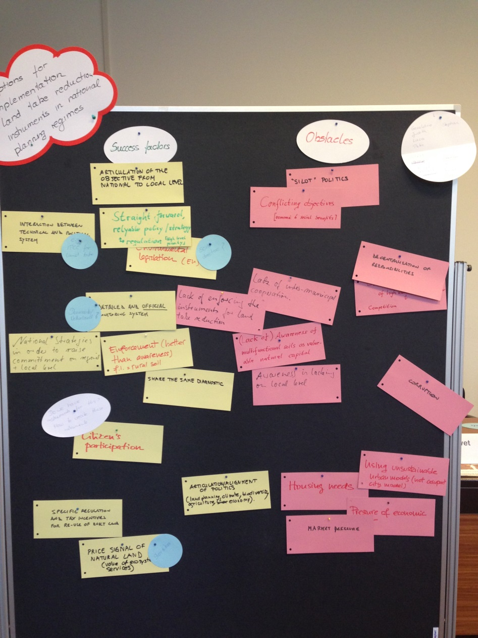

Figure 3: Results from the breakout group "Instruments for reducing land take" with success factors (yellow cards) and obstacles (red cards)

Discussing the possibility of developing a joint paper, the second group suggested that it should focus on and consider the following four points:

* Process instruments:
  + Alignment of policies
  + Citizen’s participation
  + Incorporation of long-term effects (e.g. documentation of historical land take decisions)
* Predictive instruments:
  + E.g. cost calculator (AT)
* Different planning styles
  + Focus on strategic planning; zoning-system only as an example
  + Problem: Effectiveness is difficult to assess
* Planning level / scale should be the regional level; not the local level

# Overall summary & Outlook

The SURFACE project aims at

* Studying land take and respective policies, using a cross-country comparative approach
* Initiating networking among scientists and politicians
* Involving interested decision-makers to promote the topic of land take reduction at the EU level

Within the EU, a concerted effort to reduce land take is needed to make progress toward EU-wide agreed targets.

Based on the finding of a questionnaire-based survey and the discussions during an expert workshop, a major linguistic and conceptual challenge was identified in this respect: A first important step toward such a concerted effort would be to harmonize terminology, approaches and methodologies within the EU.

Given that experts from 21 different countries collaborated with the SURFACE project during the survey phase, the project provides the rare opportunity to elaborate further on this challenge and possible ways forward together with a larger group of experts speaking many different languages and having a variety of cultural and disciplinary backgrounds.

Therefore, a tangible outcome of the expert workshop was a first sketch of a position paper with the working title „Reducing land take in Europe – Need for harmonizing the terminology (scientific viewpoint)“. Its core idea and some potential key statements were discussed at the workshop. This paper has the potential to, on the one hand, raise awareness of land take and of the need to harmonize terminology and, on the other hand, highlight opportunities for tackling land take more innovatively and in the light of the discourses and policy processes around the SDGs.

Once this position paper is published, it has furthermore the potential to facilitate the science-policy dialogue on land-take at the national and European scale. Stimulating such a science-policy dialogue at the EU-level will be the central task of the SUFRACE project during 2019/2020. In 2020, a respective workshop will be held at Brussels, with the aim of engaging more intensively with administrative experts, policy-makers and members of existing science-policy committees or fora that deal with land take in Europe.

## Appendix A: Indicators mentioned in answers to question 3.4 (quotes)

*Accentuations in bold added by the SURFACE team*

|  |  |  |
| --- | --- | --- |
| **Region** | **Country_Expert** | **Segment** |
| EU | AUSTRIA | the key indicator is **land take**, which is broadly sub-divided into **(a) settlement and transport uses** and **(b) industrial and recreational use** and followed longitudinal, however only for national territory as a whole. |
| EU | AUSTRIA | the indicator “**sealed land in m2/inhabitant**”. |
| EU | AUSTRIA | The key indicator of land take, in terms of **the annual-average new consumption of land in ha/day**, is a proper one. |
| EU | AUSTRIA | It could be **refined by** **not only administrative-statistical subdivisions** (NUTS2 – federal states; NUTS3 – (groups of) districts; LAU – municipalities but also after **qualitative types of territories such as city regions or tourist regions** as well as increasingly employ the land indicators in correlation with **further socio-economic data, including density data**. For example, Statistik Austria is meanwhile offering a comprehensive “urban-rural typology”, on municipal/LAU level, for the whole of Austria. For sure, the further progress of the LISA programme can significantly enhance the indicator possibilities. Also, for assessment reasons, case studies that **zoom-in to** **particular local land developments of various territorial settings** (like sub-urban housing, lake-side urbanization, transport networks, tourism infrastructure projects and many more…) could support the aggregated indicator-analyses by concretely **displaying what various land take mechanisms are summing up to the gross development** |
| EU | AUSTRIA | Land take measured in **settlement area per capita and municipality**.  Rationale: It is evident that an increasing population requires more infrastructure (housing, access roads, schools, etc). In many European countries land take and population growth are decoupled, meaning that land take is much higher than population growth. It is therefore necessary to relate land take to population. In a country like Austria, where living standards are already at a very high level the **ratio of land take per inhabitant (m² per capita) and municipality** should not increase |
| EU | AUSTRIA | **Weighted land take**  Rationale: One hectare of land take can have different impacts in region A and region B. For example region A has lost their last top agricultural land for a golf course, whereas region B has still ample land of the same quality and provided for urgently necessary housing. This example is of course an exaggeration, but it illustrates the issue. It would be very recommendable to monitor **land take according to soil quality or soil functions at a regional level** |
| EU | AUSTRIA | **Land recycling**  For countries with high living standards and limited land resources it will be essential to increase their **land use efficiency** in the future. In Austria (as in many other European countries) there is an enormous potential to re-use abandoned or underused infrastructure and undeveloped building plots in city centres. The European Environment Agency has recently published **a land recycling indicator for large European urban agglomerations** for the period 2006 to 2012 [18]. This indicator is a very good example for the monitoring of land recycling, a topic which will gain importance in the future |
| EU | BELGIUM_Flanders | the **additional land take (expressed in ha per day)** |
| EU | BELGIUM_Flanders | VITO describes the operationalization of the **‘ruimtebeslag’ indicator** in Flanders, which is based on the **definition of 'settlement area'** used by the European Commission, a.d. a baseline measurement for reference year 2013. This baseline measurement is a derived product of the land use file for reference year 2013 |
| EU | BELGIUM_Flanders | Based on the **‘ruimtebeslag’ indicator**, a number of **spatial indicators** were derived using other geographical information sources:  **‘ruimtebeslag’ per hectare**  **‘ruimtebeslag’ vs. Spatial destinations** assigned according to the Flemish destination plan  **Population density  Household density  Area of non-built-up space (green space)  Average height of the buildings  Floor area  Residential floor area  Employment density  Interweaving living / working  Infrastructure area** |
| EU | CZECH_REP | The most useful is **long- term evaluation of land use changes** based on data from the State Administration of Land Surveying and Cadastre |
| EU | DENMARK | **monitoring of the** **areas for settlement and traffic areas** is a good and useful indicator for measuring land take (maybe remote sensing could be used as a tool?). |
| EU | DENMARK | However, **area designations in local development plans** should probably also be used as an indicator. The plans show **potential / possible land use in near future**, and since Danish local development plans imply a right (legal claim) to build in accordance with the plan it is a fairly good forecast for **potential land take**. |
| EU | ESTONIA | I would like to suggest that **overview about the land use at least for every year** could be important for monitoring the land use changes. |
| EU | FRANCE | A suitable indicator might be a **mix of data** coming **from geolocalised building permits** (the Ministry of Ecological and Solidarity Transition has a national register of building permits with data on land uses) **and satellite images** such as Corine Land Cover but at the smaller scale (see work of Poulhes et al. 2017) |
| EU | GERMANY | The **monitoring of the areas for settlement and traffic areas** is a good and useful indicator for measuring the attainment of the 30ha target (see questions 3.2 and 3.3). Certain blurs are to be noted however still regarding **the degree of sealing of these surfaces** |
| EU | GERMANY | If you want to look at land use in a broader context, especially by establishing a bridge to SDG 15.3 and thus **to assess issues of soil threat, further indicators should be included**. In a recent expert survey in Germany (UBA, 2018a), **sealing, pollutant inputs, erosion, densification** and **loss of organic soil or loss of humus** were mentioned as indicators for such a monitoring regarding soil and land take. Yet the indicators densification and humus loss would pose challenges for implementation, because there is hardly any data available on these issues in Germany |
| EU | GREECE | **− Total sealed area over the total municipal area  − Built-up area over the total municipal area**  **− Built-up area outside planned urban zones over the municipal area outside planned urban zones  − Area covered by road infrastructure outside planned urban zones over the municipal area outside planned urban zones  − Forest area over the total municipal area  − Forest area subject to a management plan per region  − Reforested areas over the burnt area  − Degraded land over total municipal land area  − De-sealing (soil recovery) area over the total municipal area  − Number of brownfield regeneration projects in urban areas  − Green and open spaces over total settlement area** |
| EU | ITALY | **Loss of ecosystem services (as an Index) and several related indicators: habitat fragmentation, threats to pollination, carbon sequestration, natural hazards, water pollution, hydrological network and change in water runoff, change in evapo-transpiration, ecological network, loss in agricultural production, increased river sediments transportation, soil erosion…  Financial quantification of the loss in ecosystem services** |
| EU | NETHERLANDS | **transparency on the land market.** |
| EU | POLAND | **proportion of land that is degraded over total area.** |
| EU | POLAND | **annual amount of degraded/devastated land that is reclaimed.** |
| EU | POLAND | **proportion of forest areas over total area** |
| EU | POLAND | **annual amount of land turned into forest land** |
| EU | POLAND | **percentage of the country that is covered with municipal land use plans** |
| EU | PORTUGAL | **“Artificial areas, by municipality; Areas classified as urban soil per municipality; Rehabilitated mining area in relation to total area identified as contaminated; Landscape fragmentation.** |
| EU | ROMANIA | For Romania it is very important to develop a set of **indicators which can capitalize the benefits of land use for sustainable local, regional and national development**. This can also lead to a clear assessment of the progress towards implementation of SDGs |
| EU | SLOVAKIA | Therefore, it is necessary to ensure the monitoring of **changes in soil quality** carried out to a sufficient extent |
| EU | SLOVAKIA | We need more **indicators focused on influence users of territory (as users of rural area, residents, visitors and entrepreneurs)**, and also as **cross-section indicators**. E.g. we need know how is **situation with employment in agro sector** to total agricultural area on municipal or district level. Not only on national or regional level! Also we need a **count of days without precipitation** that was not equal with rainfall water or absorbed water in past (from roof, reservoirs and etc.) |
| EU | SLOVENIA | CORINE land cover provides very useful **categories of land use/cover** that **differentiate** **land use also within artificial areas**. However, for addressing several relevant questions with regard to a small country like Slovenia, the size of the minimal polygon is still too large. |
| EU | SPAIN | **Land occupation (land uses: artificial areas...** |
| EU | SPAIN | Green spaces and biodiversity. Depreciation of natural spaces. Maps **of soil erosion, contamination of aquifers** |
| EU | SPAIN | **- Mobility and infrastructure** |
| EU | SPAIN | **- Urban metabolism (compactness, density, residential intensity, public space, energy efficiency, use of resources ...** |
| EU | SPAIN | Use of national accounts systems for **accounting sustainability policies** and to make optimal decisions to reduce land take processes |
| Non-EU | BRAZIL | The availability of more detailed **data about the regions where land changed use**, and the policy treatment of such data to **understand under which processes they took place.** |
| Non-EU | CANADA | **Agricultural Land Conversion**: total hectares of observable permanent land-use change from agricultural use to non-agricultural use. |
| Non-EU | CANADA | **Agricultural** **Land Fragmentation**: Tracks the increase in the number of agricultural land parcels that are between 10 and 80 acres in size (smaller parcel sizes) |
| Non-EU | CANADA | **Conserved Land (Area)**: total combined area of conserved land on public lands. |
| Non-EU | CANADA | **Efficient Use of Land**: a strategy that promotes reducing **the human footprint** on the provincial landscape. Objective is to minimize over time the amount of land required for development of the built environment. This indicator is under development |
| Non-EU | CANADA | **Land Retained in Native Vegetation (Area)**: total area on public land retained as native vegetation. It is calculated by the total area of the public land base minus the amount of **human footprint** (or land disturbance) for each year. |
| Non-EU | CANADA | **Land Disturbance on Productive Land Base on Public Land (Area)**: Area of land disturbance on the productive land base of public lands. The Alberta Biodiversity Monitoring Institute (ABMI) **measures human footprint** annually in 3 km by 7 km areas sampled systematically across the province. |
| Non-EU | CANADA | Other studies examining land use change in the province have used different indicators from those used by Alberta Agriculture and Forestry to measure land use change. For example, Qiu et al. (2015) used **patch density, mean patch size, edge density, mean-perimeter to area ration and effective mesh size** as indicators of fragmentation. |
| Non-EU | CHINA | Indicators concerning **environmental and ecological condition** |
| Non-EU | CHINA | Indicators concerning **social equity** |
| Non-EU | CHINA | Indicators **concerning public goods, e.g. public infrastructures, assess to education, health** etc. |
| Non-EU | CHINA | Indicators concerning **food security (quantity of farmland)** |
| Non-EU | CHINA | Indicators concerning **economic development, increasing/decreasing income for public/private stakeholders** etc. |
| Non-EU | SWITZERLAND | the **amount of settlement area used per inhabitant** |
| Non-EU | SWITZERLAND | **Loss of agricultural land** |
| Non-EU | SWITZERLAND | There are other indicators like “**growth of built-up areas**” or “**amount of total area used by settlement purposes**” that tend to sound not very alarming (growth rates of 1% per year or “7.5% of the area is covered by artificial surfaces” don’t seem to be overly problematic) |
| Non-EU | SWITZERLAND | Etablierte und unbestrittene Indikatoren sind die **Siedlungsfläche und das Siedlungsflächenwachstum pro Zeiteinheit sowie die Siedlungsflächenbeanspruchung pro Kopf und pro Arbeitsplatz** |
| Non-EU | SWITZERLAND | Meiner Einschätzung nach genügt es nicht, die Siedlungsfläche bzw. das Siedlungswachstum zu betrachten. Die **Anordnung und Verteilung sowie die Degradierung der wertvollsten Böden** (z.B. bestes  Ackerland) sind wichtige Teilaspekte. |

## Appendix B: Program of the SURFACE Expert Workshop in April 2019



1. http://www.ipex.eu/IPEXL-WEB/dossier/files/download/082dbcc53267f2ec01329013dd05019b.do
2. https://www.eea.europa.eu/data-and-maps/indicators/land-take-2
3. https://www.eea.europa.eu/data-and-maps/indicators/land-take-3/assessment/view
4. <https://ec.europa.eu/eurostat/documents/3217494/9237449/KS-01-18-656-EN-N.pdf/2b2a096b-3bd6-4939-8ef3-11cfc14b9329>
5. European Commission (2011): Roadmap to a Resource Efficient Europe. https://eur-lex.europa.eu/legal-content/EN/TXT/PDF/?uri=CELEX:52011DC0571&from=EN
6. https://eur-lex.europa.eu/legal-content/EN/TXT/PDF/?uri=CELEX:32013D1386&from=EN
7. UN General Assembly 2012. Outcome document “The Future We Want” (A/RES/66/288, p. 40, para 206), https://www.un.org/ga/search/view_doc.asp?symbol=A/RES/66/288&Lang=E
8. https://sustainabledevelopment.un.org/sdg11
9. https://sustainabledevelopment.un.org/sdg15
10. BRICS = acronym for Brazil, Russia, India, China, South Africa
11. E.g.: Umweltökonomische Gesamtrechnungen der Länder, https://www.statistikportal.de/sites/default/files/2018-08/m_flaeche_3_Stand-2018_0.pdf
12. https://www.umweltbundesamt.at/umweltsituation/raumordnung/rp_flaecheninanspruchnahme
13. See also: https://www.umweltbundesamt.at/umweltsituation/raumordnung/rp_flaecheninanspruchnahme/rp_definitionen/
14. “The NSTRAT from 2002 states under key objective no. 13 that the soil sealing shall be reduced down to 2.5 ha/day by 2010, which is confusingly termed “down to one tenth by 2010” compared to the 25 ha/day of land take before 2002. It is obviously a matter of mixed terminology between land take (Flächenverbrauch; now named Flächeninanspruchnahme) and soil sealing (Versiegelung).”
15. “Land take: pozidava […] Soil sealing: pozidava“
16. “Land use: Land use is based on the functional dimension of land for different human purposes or economic activities. Typical categories for land use are settlement and traffic (e.g. housing, industrial use, transport, agricultural use, forest or nature protection areas).

    Land take / land consumption: Change in the amount of agricultural, forest and other semi-natural and natural land taken by urban and other artificial land development. It includes areas sealed by construction and urban infrastructure as well as urban green areas and sport and leisure facilities. The main drivers of land take are grouped in processes resulting in the extension of: housing, services and recreation; industrial and commercial sites; transport networks and infrastructures; mines, quarries and waste dumpsites; construction sites (EEA 2017).

    Land development: Conversion of undeveloped land into construction ready housing, commercial, or industrial building sites as well as related (traffic) infrastructure. Land development process involves improvements that have indefinite life, such as draining, dredging, excavating, filling, grading, paving, brownfield redevelopment etc.”
17. https://esdac.jrc.ec.europa.eu/public_path/shared_folder/ENSA/ENSA_Bratislava_2017_Jaroslava_Sobocka.pdf
18. Strategische visie van het Beleidsplan Ruimte Vlaanderen (p. 26): https://www.ruimtevlaanderen.be/Portals/108/Strategische_Visie_rgb_1.pdf
19. In May 2019, i.e. after the SURFACE survey had been completed, elections were held in Flanders. At the time this report was finalised (Oct. 2019), the future of the 0 ha/day target was very unclear, since the first draft of the coalition agreement had removed it from the agenda of the Flemish government.
20. Key Objective 13 of the Austrian Strategy for Sustainable Development (p. 70): http://www.nies.go.jp/db/sdidoc/strategie020709_en.pdf
21. https://www.bmnt.gv.at/dam/jcr:795a66f4-6f21-4f89-9991-51fcf3b6c50e/%C3%96STRAT_2010.pdf
22. PNDD Luxemburg, Un Luxembourg durable pour une meilleure qualité de vie (2010), p. 10, 35.
23. See also e.g. Bai et al. (2016): New ecological redline policy (ERP) to secure ecosystem services in China. Land Use Policy 55: 348-351
24. https://www.nachhaltigkeitsrat.de/en/sustainability-policy-in-germany/
25. See e.g.: <https://bpej.vumop.cz> and http://www.podnemapy.sk/default.aspx
26. http://gisak.vsb.cz/GIS_Ostrava/GIS_Ova_2005/Sbornik/en/Referaty/vlasak.pdf
27. http://www.skgeodesy.sk/en/
28. https://www.lucccz.cz/module.Pagesimple/?url=en
29. See also: http://kgk.uni-obuda.hu/sites/default/files/24_Palsova_Bandlerova_Meliskova_Schwarcz.pdf
30. http://www.qp.alberta.ca/documents/Acts/A26P8.pdf
31. http://www.tdc-alberta.ca/basics.html
32. https://landuse.alberta.ca/ConservationStewardship/ConservationStewardshipTools/Pages/default.aspx
33. Ibid.
34. Vincent Renard (2007): Property rights and the ‘transfer of development rights’. Questions of efficiency and equity. Town Planning Review 78/1. https://doi.org/10.3828/tpr.78.1.4
35. See [www.flaechenhandel.de](http://www.flaechenhandel.de)
36. https://www.raumordnung-noe.at/index.php?id=148
37. http://www.bmz.de/en/zentrales_downloadarchiv/Presse/HLPF-Bericht_final_EN.pdf
38. In September 2019, the political situation in Flanders made it difficult to judge whether Flanders will remain among the pioneers in future. See also footnote 19.
39. Austria, Belgium, Denmark, Estonia, France, Germany, Italy, The Netherlands, Poland, Slovenia, Slovakia, Spain. The representative from Greece had to cancel her participation at short notice.
40. See e.g.: Humer, Sedlitzky, Brunner (2019): Journal of Housing and the Built Environment 34:331-344